⚽ FIFA 21 Player Analytics — SQL Project Report
Author: Rohan
Tools Used: MySQL Command Line Client, MySQL Workbench
Dataset: FIFA 21 Complete Player Dataset (Kaggle)

📌 1. Project Overview
This project analyzes the FIFA 21 Complete Player Dataset using SQL.
The goal is to explore player performance, potential, market value, physical attributes, and scouting metrics.
This project demonstrates:
- SQL data import using command line
- Data validation in MySQL Workbench
- Sports analytics
- Player ranking and scouting logic
- Feature engineering
- Advanced SQL techniques (window functions, attribute scoring, clustering logic)
- Clean, structured reporting
This project is designed for portfolio use and interview discussions.

📦 2. Dataset Description
The dataset contains detailed information about 18,000+ professional football players from FIFA 21.
Key Columns
- sofifa_id — Unique player ID
- short_name / long_name — Player names
- age, height_cm, weight_kg — Physical attributes
- nationality, club_name, league_name — Player background
- overall, potential — FIFA ratings
- value_eur, wage_eur — Market value & salary
- player_positions — Primary & secondary positions
- preferred_foot — Left or right
- pace, shooting, passing, dribbling, defending, physic — Core attributes
- goalkeeping stats — For GK players
- attacking, skill, movement, power, mentality, defending — Sub-attributes
- position ratings (ST, CAM, CB, etc.) — Role-specific performance
Why this dataset is valuable
- Rich numerical attributes
- Perfect for ranking, scouting, and analytics
- Ideal for SQL + data science style queries
- Allows exploration of player performance, potential, and market value

🧱 3. Database & Table Creation
Create database
CREATE DATABASE fifa;
USE fifa;
Create table (full schema)
(Matches all columns in players_21.csv)
CREATE TABLE players_21 (
sofifa_id INT,
player_url TEXT,
short_name VARCHAR(255),
long_name VARCHAR(255),
age INT,
dob VARCHAR(20),
height_cm INT,
weight_kg INT,
nationality VARCHAR(100),
club_name VARCHAR(255),
league_name VARCHAR(255),
league_rank INT,
overall INT,
potential INT,
value_eur BIGINT,
wage_eur BIGINT,
player_positions VARCHAR(100),
preferred_foot VARCHAR(20),
international_reputation INT,
weak_foot INT,
skill_moves INT,
work_rate VARCHAR(50),
body_type VARCHAR(50),
real_face VARCHAR(10),
release_clause_eur BIGINT,
player_tags TEXT,
team_position VARCHAR(50),
team_jersey_number INT,
loaned_from VARCHAR(255),
joined VARCHAR(20),
contract_valid_until VARCHAR(20),
nation_position VARCHAR(50),
nation_jersey_number INT,
pace INT,
shooting INT,
passing INT,
dribbling INT,
defending INT,
physic INT,
gk_diving INT,
gk_handling INT,
gk_kicking INT,
gk_reflexes INT,
gk_speed INT,
gk_positioning INT,
player_traits TEXT,
attacking_crossing INT,
attacking_finishing INT,
attacking_heading_accuracy INT,
attacking_short_passing INT,
attacking_volleys INT,
skill_dribbling INT,
skill_curve INT,
skill_fk_accuracy INT,
skill_long_passing INT,
skill_ball_control INT,
movement_acceleration INT,
movement_sprint_speed INT,
movement_agility INT,
movement_reactions INT,
movement_balance INT,
power_shot_power INT,
power_jumping INT,
power_stamina INT,
power_strength INT,
power_long_shots INT,
mentality_aggression INT,
mentality_interceptions INT,
mentality_positioning INT,
mentality_vision INT,
mentality_penalties INT,
mentality_composure INT,
defending_marking INT,
defending_standing_tackle INT,
defending_sliding_tackle INT,
goalkeeping_diving INT,
goalkeeping_handling INT,
goalkeeping_kicking INT,
goalkeeping_positioning INT,
goalkeeping_reflexes INT,
ls VARCHAR(10),
st VARCHAR(10),
rs VARCHAR(10),
lw VARCHAR(10),
lf VARCHAR(10),
cf VARCHAR(10),
rf VARCHAR(10),
rw VARCHAR(10),
lam VARCHAR(10),
cam VARCHAR(10),
ram VARCHAR(10),
lm VARCHAR(10),
lcm VARCHAR(10),
cm VARCHAR(10),
rcm VARCHAR(10),
rm VARCHAR(10),
lwb VARCHAR(10),
ldm VARCHAR(10),
cdm VARCHAR(10),
rdm VARCHAR(10),
rwb VARCHAR(10),
lb VARCHAR(10),
lcb VARCHAR(10),
cb VARCHAR(10),
rcb VARCHAR(10),
rb VARCHAR(10)
);

🖥️ 4. Importing the Dataset Using CMD
Move the CSV to:
C:\Users\itsro\OneDrive\Desktop\players_21.csv
Import command
USE fifa;

LOAD DATA LOCAL INFILE 'C:\\Users\\itsro\\OneDrive\\Desktop\\players_21.csv'
INTO TABLE players_21
FIELDS TERMINATED BY ','
ENCLOSED BY '"'
LINES TERMINATED BY '\n'
IGNORE 1 ROWS;

🔍 5. Data Validation in MySQL Workbench
5.1 — Display first 5 rows
SELECT * FROM players_21 LIMIT 5;
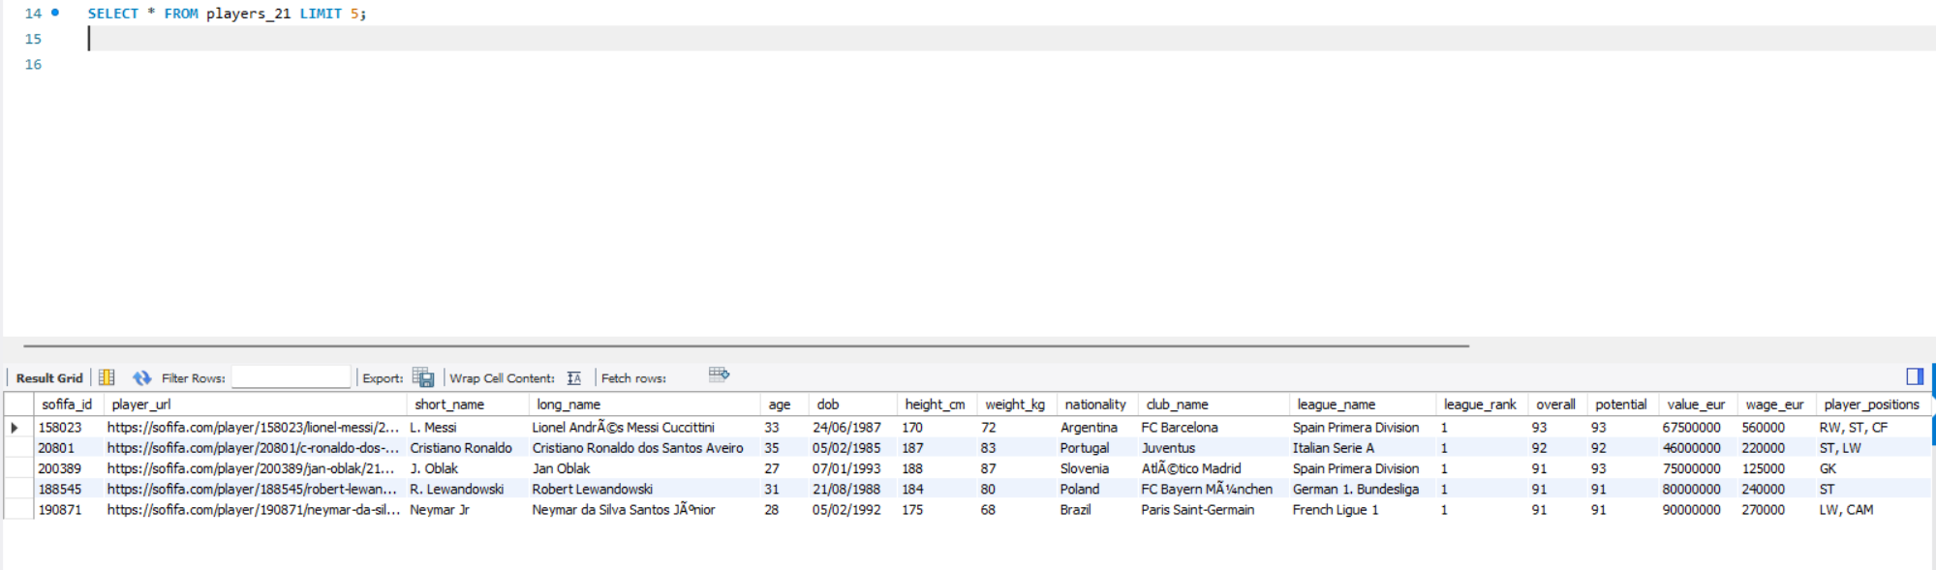
5.2 — Count total rows
SELECT COUNT(*) FROM players_21;

📘 6. Basic SQL Analysis (10 Tasks)

1. Top 10 players by overall rating
SELECT short_name, club_name, overall
FROM players_21
ORDER BY overall DESC
LIMIT 10;
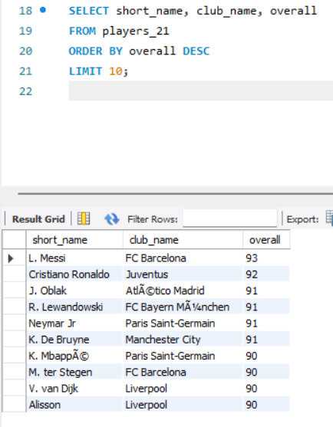

2. Top 10 youngest players with high potential
SELECT short_name, age, potential
FROM players_21
WHERE age < 20
ORDER BY potential DESC
LIMIT 10;
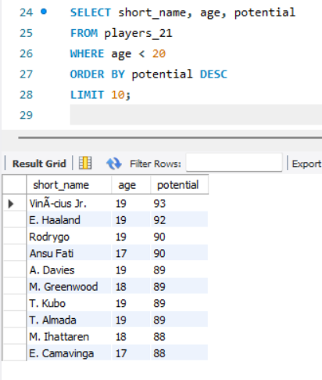

3. Most valuable players (market value)
SELECT short_name, club_name, value_eur
FROM players_21
ORDER BY value_eur DESC
LIMIT 10;
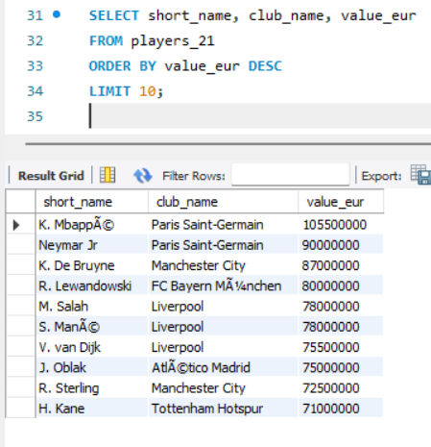

4. Players with highest wages
SELECT short_name, club_name, wage_eur
FROM players_21
ORDER BY wage_eur DESC
LIMIT 10;
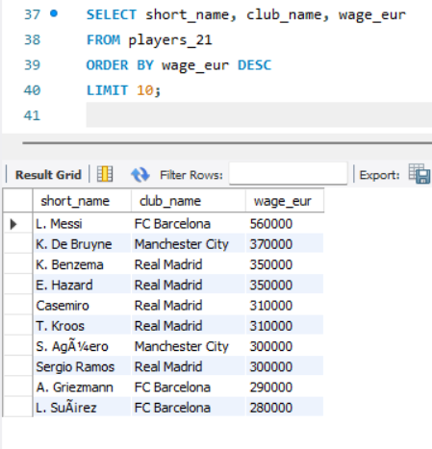

5. Count players by nationality
SELECT nationality, COUNT(*) AS total_players
FROM players_21
GROUP BY nationality
ORDER BY total_players DESC;
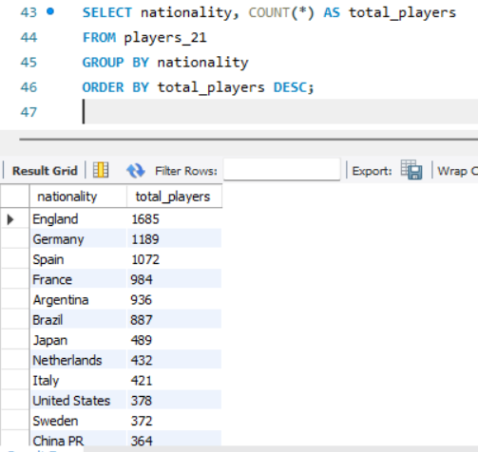

6. Best players by position (e.g., ST)
SELECT short_name, overall
FROM players_21
WHERE team_position = 'ST'
ORDER BY overall DESC
LIMIT 10;
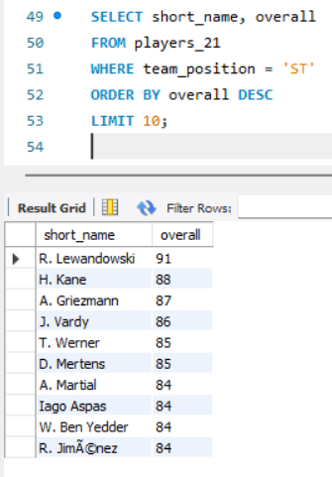

7. Clubs with the most players
SELECT club_name, COUNT(*) AS total_players
FROM players_21
GROUP BY club_name
ORDER BY total_players DESC;
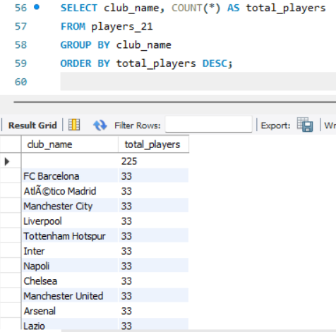

8. Average attributes by nationality
SELECT nationality,
AVG(overall) AS avg_overall,
AVG(potential) AS avg_potential
FROM players_21
GROUP BY nationality
ORDER BY avg_overall DESC;
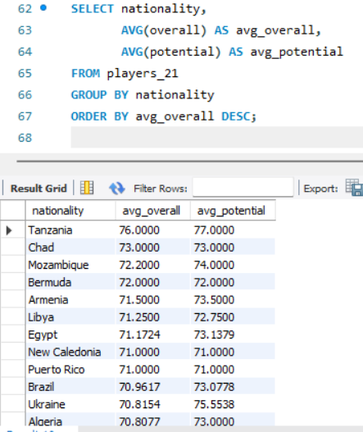

9. Tallest players
SELECT short_name, height_cm
FROM players_21
ORDER BY height_cm DESC
LIMIT 10;
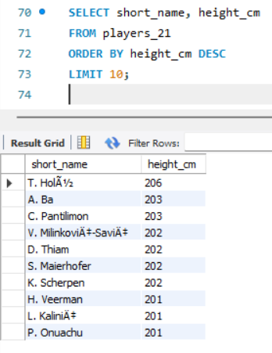

10. Strongest players (physical rating)
SELECT short_name, physic
FROM players_21
ORDER BY physic DESC
LIMIT 10;
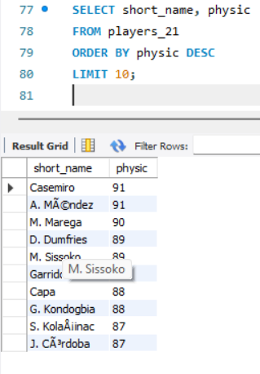

🔥 7. Advanced SQL Analysis (15 Tasks)

1. Calculate “Potential Growth”
SELECT short_name, overall, potential,
(potential - overall) AS growth
FROM players_21
ORDER BY growth DESC;
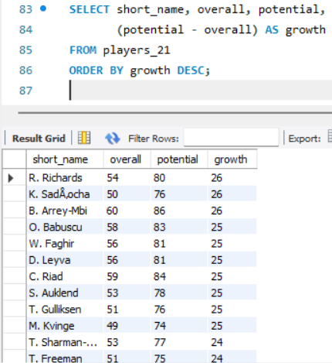

2. Build a custom “Attacking Score”
SELECT short_name,
(attacking_finishing + attacking_volleys + shooting + pace) / 4 AS attacking_score
FROM players_21
ORDER BY attacking_score DESC;
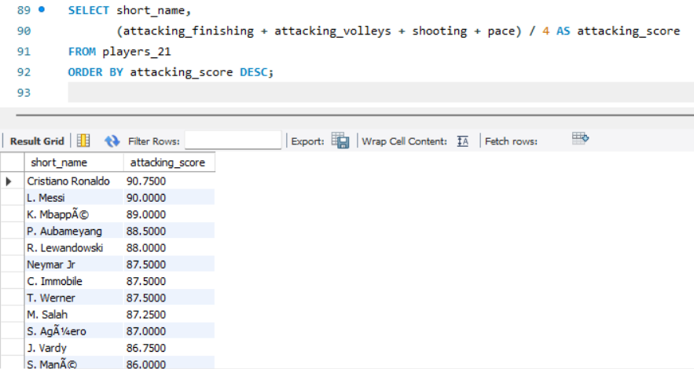
3. Build a “Midfield Score”
SELECT short_name,
(passing + dribbling + movement_reactions + movement_balance) / 4 AS midfield_score
FROM players_21
ORDER BY midfield_score DESC;
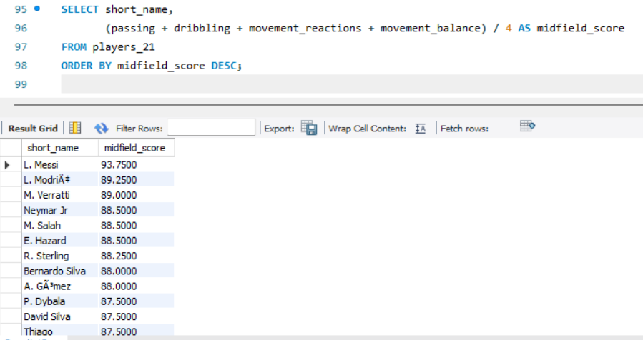
4. Build a “Defensive Score”
SELECT short_name,
(defending + defending_marking + defending_standing_tackle + defending_sliding_tackle) / 4 AS defensive_score
FROM players_21
ORDER BY defensive_score DESC;
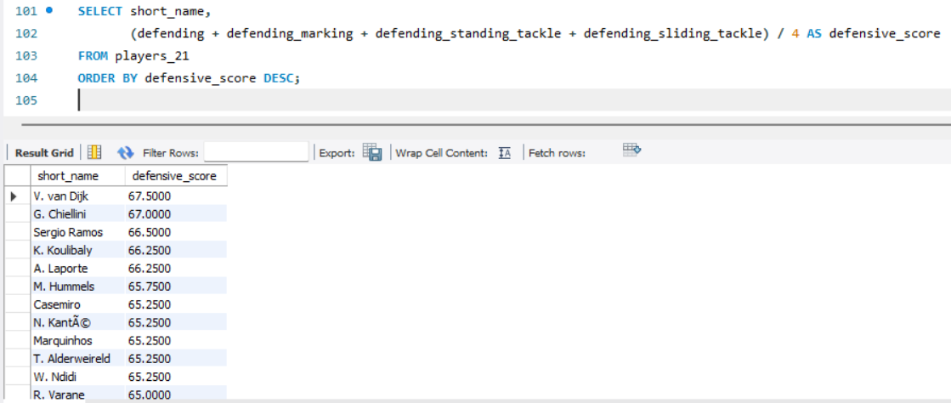
5. Best players under age 23 (overall + potential)
SELECT short_name, age, overall, potential
FROM players_21
WHERE age <= 23
ORDER BY potential DESC, overall DESC;
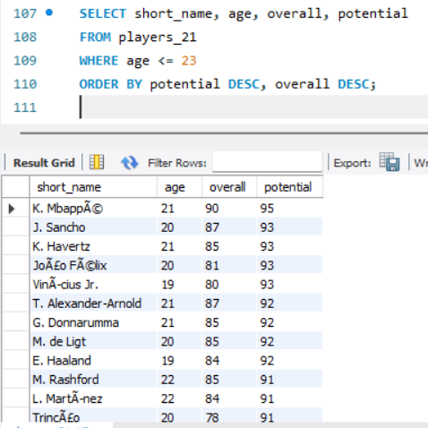
6. Best free-kick takers
SELECT short_name, skill_fk_accuracy
FROM players_21
ORDER BY skill_fk_accuracy DESC
LIMIT 10;
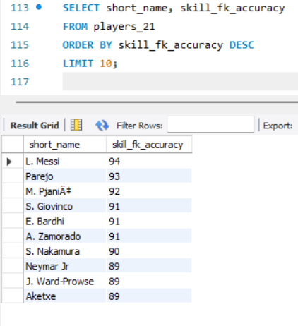

7. Best dribblers
SELECT short_name, dribbling
FROM players_21
ORDER BY dribbling DESC
LIMIT 10;
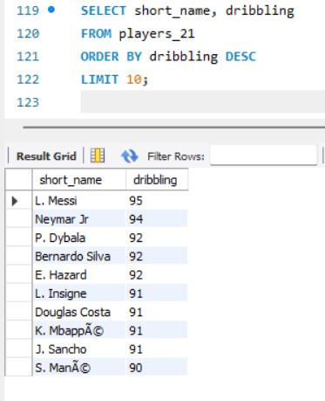

8. Best passers
SELECT short_name, passing
FROM players_21
ORDER BY passing DESC
LIMIT 10;
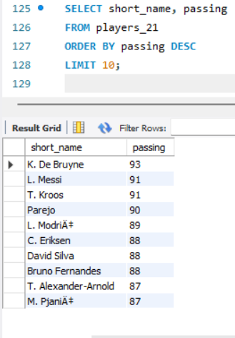

9. Best goalkeepers
SELECT short_name,
gk_diving, gk_handling, gk_kicking, gk_reflexes, gk_positioning
FROM players_21
ORDER BY gk_reflexes DESC;
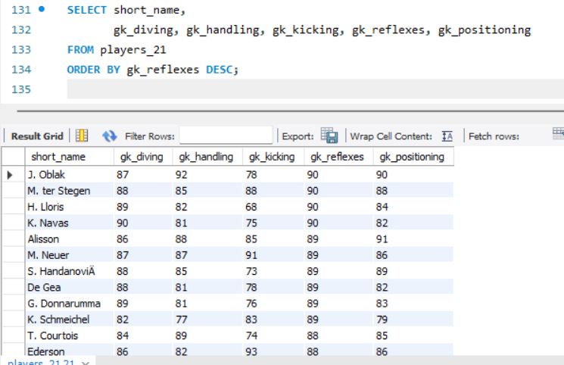

10. Most aggressive players
SELECT short_name, mentality_aggression
FROM players_21
ORDER BY mentality_aggression DESC
LIMIT 10;
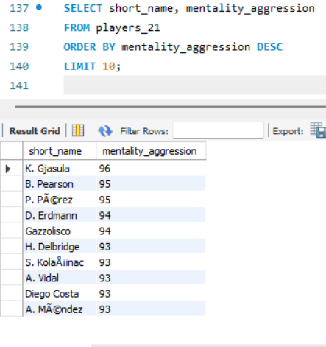

11. Most composed players
SELECT short_name, mentality_composure
FROM players_21
ORDER BY mentality_composure DESC
LIMIT 10;
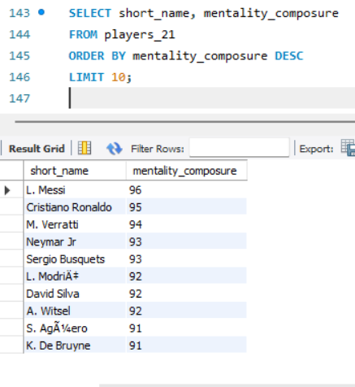

12. Best players by league
SELECT league_name, short_name, overall
FROM players_21
ORDER BY league_name, overall DESC;
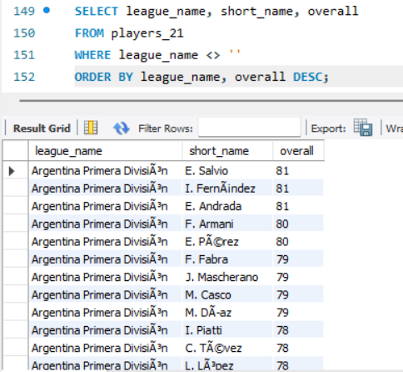

13. Players with highest release clause
SELECT short_name, release_clause_eur
FROM players_21
ORDER BY release_clause_eur DESC
LIMIT 10;
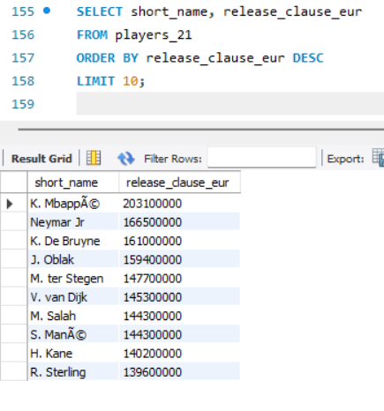

14. Players with the most traits
SELECT short_name,
LENGTH(player_traits) - LENGTH(REPLACE(player_traits, ',', '')) + 1 AS trait_count
FROM players_21
ORDER BY trait_count DESC;
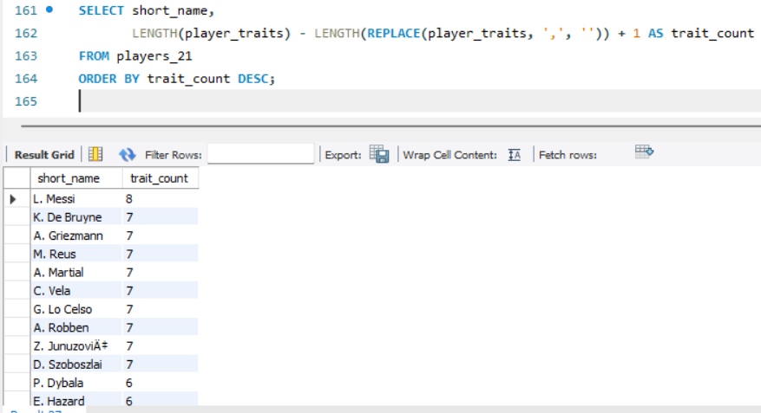

15. Build a “Scouting Index” (custom metric)
(Weighted score combining key attributes)
SELECT short_name,
(overall*0.4 + potential*0.3 + pace*0.1 + dribbling*0.1 + passing*0.1) AS scouting_index
FROM players_21
ORDER BY scouting_index DESC;
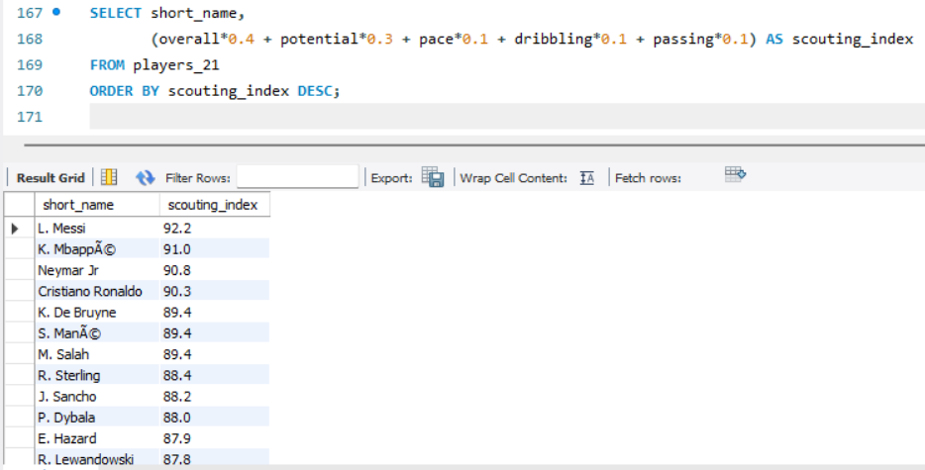

🏁 8. Conclusion
This FIFA SQL project provides a comprehensive analysis of professional football players using real-world data.
Through this project, we explored:
- Player performance
- Potential growth
- Market value
- Attribute-based scouting
- Position-specific rankings
- League and nationality comparisons
- Custom scoring systems
- Feature engineering for data science
The project demonstrates strong SQL capabilities, including:
- Data import using command line
- Data cleaning and validation
- Aggregations and grouping
- Window functions
- Attribute scoring
- Analytical storytelling

